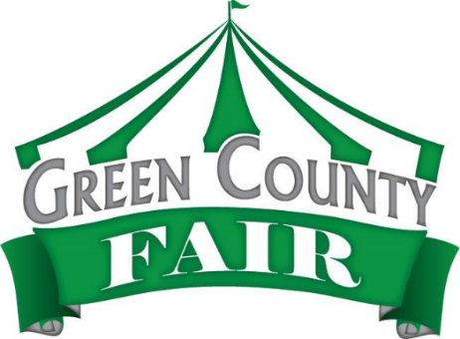

Website: www.greencountyfair.net
Email: greencountyfair.net
Phone: 608-325-9159

The Green County Fair Welcomes You To Our
2019 Military Appreciation Day
Wednesday July 17, 2019

We will be honoring our past and present military men and women of
Green County Wisconsin during the 7:00 p.m.
Professional Bull Riding and Barrel Racing performance.

For Military Personnel Only:

- 1 free ticket to the fair available at any gate. Must show military I.D. Valid on this day only.
- $5.00 food voucher available only at the 4-H Youth and Action Building from 1:00 to 6:00 p.m.
- Reserved seating section for military personnel and their families at the performance.
- Arena tour and meet and greet with bull riders from 5:30 p.m. to 6:30 p.m.
- Autograph session with the contestant’s post performance.

Thank you for your service!

2019 Green County Fair Board of Directors

------------------------------------------------------------------------------------------------------------
Green County Agricultural Society & Mechanics Institute
2600 10th Street
Monroe, WI 53566

