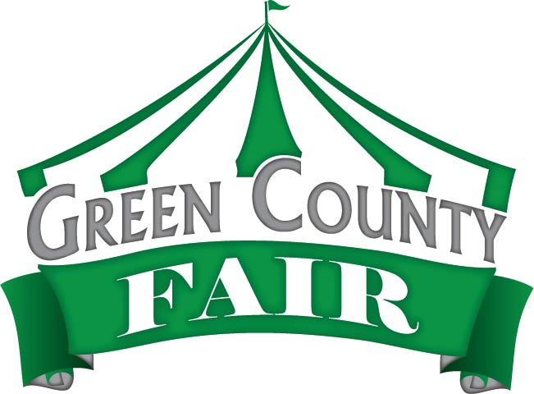
Green County Fair
Summer Reading Program

By reading a minimum of five books between the end of your school year and July 17th, you can earn a coupon worth $10.00 off of a wristband for carnival rides at the Green County Fair. This program is open to all kids in grades 4K-12. One coupon per person may be turned in to earn a $10.00 off daily rides coupon. The coupon is good any day of the fair and for the entire time rides are going. Here’s what you need to do:
- Read five books by July 19th
- Fill out this form and bring it with you to the fair
- Take this form to the Fair Office to receive your coupon. It’s that easy!

Your name: _______________________________________________ Grade: _____________

School: ___________________________________ City: _______________________________

Title of Book | Author | What you liked/learned from this book
1.

2.

3.

4.

5.

See you at the fair!!
Green County Fair
Main Events
**Events and times subject to change**

Wednesday, July 17th: Military Appreciation Day
- David Landan 12:00 - 4:00 pm in the Hospitality Tent
- 4-H Speaking 2:30 - 3:30 pm in the Hospitality Tent
- Beth Kille 4:00 – 6:00 pm in the Hospitality Tent
- Green County Bulls and Barrels at 6:30 pm in the Grandstands

Thursday, July 18th
- Tim Glander 12:00 – 1:00 pm in the Hospitality Tent
- Balloons 1:30 – 2:00 pm in the Hospitality Tent
- Magic 2:30 – 3:30 pm in the Hospitality Tent
- Ken Lonnquist 12:00 – 2:00 pm in the Hospitality Tent
- Badger State Tractor/Truck Pull at 6:30 pm in the Grandstands

Friday, July 19th: First Responders Appreciation Day
- Fairest of the Fair 12:00 – 2:00 pm in the Hospitality Tent
- 4-H Speaking 2:30 – 3:30 pm in the Hospitality Tent
- Spudmobile 3:00 – 6:00 pm
- Skid Steer Rodeo 4:00 – 6:00 pm in the Grandstands
- Green County Local Truck and Tractor Pull at 7:00 pm in the Grandstands

Saturday, July 20th: Kid’s Day- free admission to those 11 and under until 1:30pm
- Pedal Pull at 10:00am; in front of Exhibition Hall
- Garden Tractor / ATV Pullers 8:30 am Grandstands
- Colony Brands Championship Tug of War 10 am
- Horse Pull 1 pm in Grandstands
- Casey & Greg 1:30 – 3:30 pm in the Hospitality Tent
- Fair Music Contest Winner 4:00 – 5:00 pm in the Hospitality Tent
- Fur and Feather Auction at 10:00 am
- Youth Livestock Auction at 12:30 pm
- Master Showman competition beginning at 5:00 pm
- Chris Kroeze Concert 8:00 pm in the Grandstands followed by Fireworks

Sunday, July 21st: Pioneer Day ($5 admission for those 65+)
- Antique Tractor Pull beginning at 8:30 am
- 4-H Awards 10:30 am – 12:00 pm in the Hospitality Tent
- Cheese Auction and Dairy Youth Auction 12:00 – 4:00 pm in the Hospitality Tent
- Brew City All-Star Heavyweight Wrestling at 2:00 pm In Show Barn
- Demolition Derby at 5:00 pm in the Grandstands

